

**Accenture Delivery Suite**



CC to RTC Migration Instructions Guide

November 2015 FY16Q1

Final

Accenture Delivery Tools

Accenture Methods Tools

©2016 Accenture. All rights reserved. Accenture, its logo, and 'High Performance. Delivered.' are  
trademarks of Accenture. Other trademarks used in these materials are the properties of their respective owners. Confidential Information of Accenture. For use by Accenture personnel or on Accenture projects.

Contents

Introduction 3

Clear Case Synchronizer 4

Prerequisites for Clear Case Synchronizer 4

Limitations 4

Install IBM Installation Manager 5

Install CC Synchronizer 6

Migration Procedure 9

Create and configure the RTC Project Area 9

Configure the CC Importer 12

Import the Clear Case UCM baselines 21

Verifying the import 23

Find Stream Selector 26

Find component list in RTC 27

Troubleshooting 28

Rollback Procedure 30

# Introduction

This document provides the instructions for Clear Case (CC) to Rational Team Concert (RTC) migration where the projects have UCM integrated with CC.

**Note1:** **Please ensure not to proceed with Clear Case migration until the Clear Quest migration is completed.**

**Note2: This procedure is certified on ADT RTC process template v6.2 on CLM6.0.**

# Clear Case Synchronizer

The Rational Clear Case Synchronizer is a data migration tool between Rational Clear Case and Rational Team Concert source control which will be used to migrate CC data to the RTC unidirectional.

# Prerequisites for Clear Case Synchronizer

* Clear Case 8.0.0.8 must be installed on the computer where Rational Clear Case is installed.
* Rational Clear Case Synchronizer v5.0 must be installed on the Clear Case v8.0.0.8 server.
* Install and set up a CLM6.0 server.
* Install RTC Eclipse Client 6.0 on Configuration Management (CM) server.
* RTC project area is created and added all active CC users with “team member” process roles into same RTC PA.
* Port#443 should be opened from CLM server to CM server.
* Port#8081, 8444, 9443, 443 and 80 should be implemented from CM server to CLM server.
* The user performing the migration activity should have JazzAdmin repository permissions and must have all roles in the RTC Project Area.
* Download CC&CQ Migration package from IBM Rational\ADT FY15 Q4 -- Pilot -- available Aug 2015\CC&CQ Migration to CLM.
* All respective activities should be closed before applying full baseline.
* Full Baseline should be applied on respective stream and it is recommended to do the same before migration.

# Limitations

1. Full version history of the individual elements cannot be migrated.
2. Once the baseline is applied and migrated, all the files being migrated map themselves to the last activity used for check-in/check-out before the baseline was applied.

# Install IBM Installation Manager

**Note:** CQ Synchronizer supports Installation Manager v1.6.3 or later. Below are the steps to install Installation Manager v1.6.3. **If it is already installed, then ignore this section.**

1. Locate the installation folder for IBM Installation Manager.

E.g. IBM Rational\IBM Installation Manager\IBM Installation Manager v1.6.3\agent.installer.win32.win32.x86_1.6.3000.20130510_2243

1. Double click on **Install.exe** to start installing Installation Manager V1.6.3 and click **Next** to start installation.
2. Click on **I accept the terms in the License agreements** option and click **Next**.
3. Install the installation manager in the directory so that the path does not contain any space. **e.g.** E:\IBM\
4. Select a location for Installation manager and click **Next**.
5. Click on **Install**.
6. Click on **Restart Installation Manager**.

# Install CC Synchronizer

**Procedure:**

1. Download the Installation Manager Repository package “RTC-ClearQuest-Synchronizer-repo-5.0” for windows from location found at **IBM Rational\CLM\v5.0\ RTC-ClearCase-Synchronizer-repo-5.0.zip**
2. Extract **“RTC-ClearCase-Synchronizer-repo-5.0.zip”** locally at any temporary location.
3. Open IBM Installation Manager and go to File 🡪 Preferences and then select Add Repository.
4. For the Repository location, browse to the directory where the extracted the .zip file is placed and open the repository.config file.
5. Click OK to finish the adding preferences, and then click on Install to start the installation process.

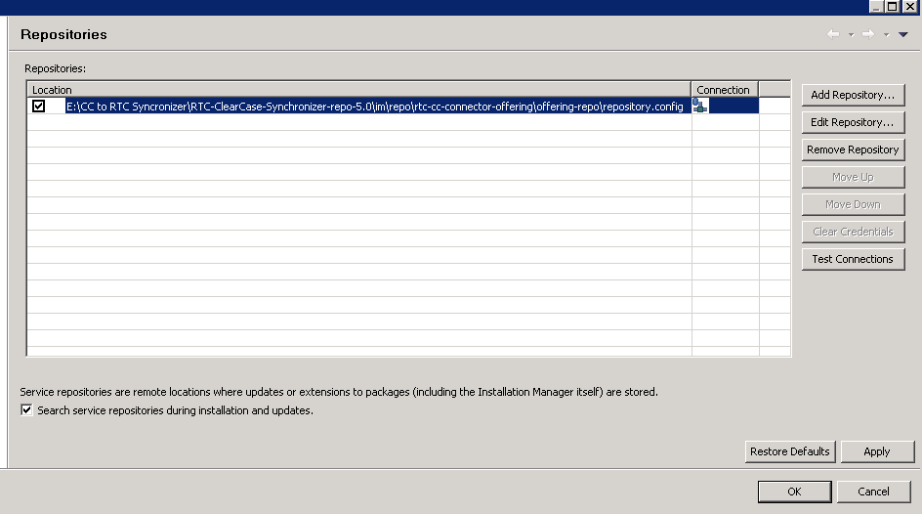

1. In the Install Packages window, select the following packages to install and click Next.
2. Read and accept the license agreement by selecting radio button. Click Next.
3. In the Architecture Selection section, select 32-bit and Click on Next.

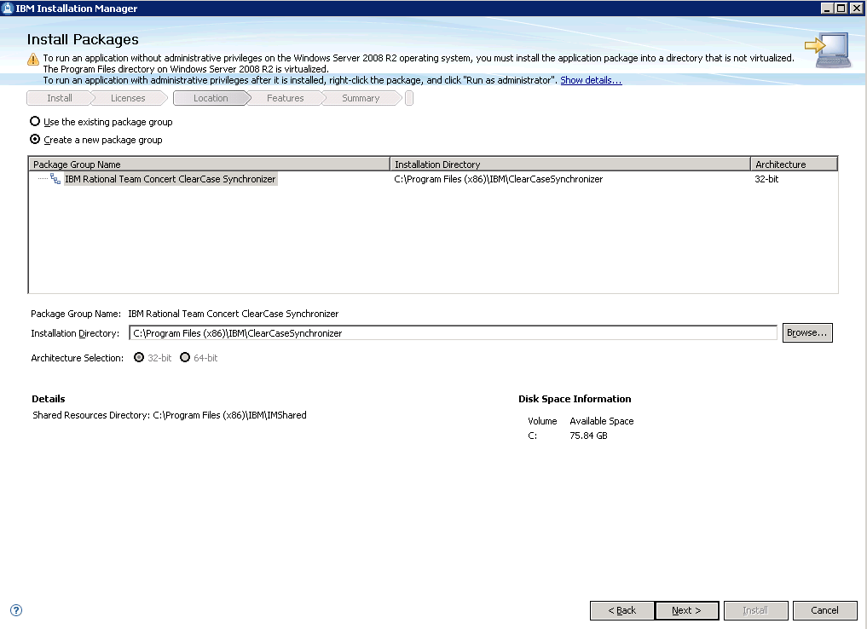

1. To install additional languages, select one or more languages and click Next.
2. In the Install Packages window, select the packages “Rational Team Concert – Clear Case Synchronizer 5.0” and click Next.

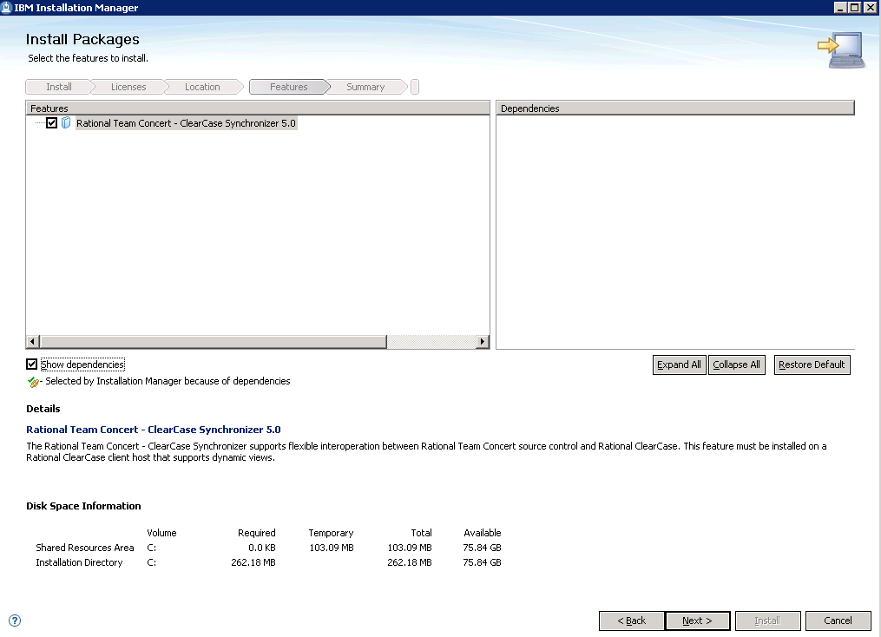

1. Click on Install.

# Migration Procedure

Steps for migrating Rational Clear Case components in Rational Team Concert:-

## Create and configure the RTC Project Area

1. Login to the Jazz Change and Configuration Administration page at [***https://myhost.example.com:9443/ccm/admin***](https://myhost.example.com:9443/ccm/admin)
2. Go to Project Areas page and create a Master Project Area based on the "ADT RTC Process Template -6.2.zip" Process Template. Also, create a Child PA based on “Unconfigured process template” and associate them.
3. Create a new user with the following properties:

**Note:** This step can be skipped if the user is headless account, else please assign the mentioned licenses.

**Name**: <user name>   
**User ID**: <enterprise id>  
**Email address**: <enterprise email id >  
**Repository groups**: JazzUsers  
**Licenses**: Rational Team Concert - Clear Case Synchronizer

1. Edit the Master Project Area's permissions to grant "Item Connectors", "Process", "Work Items", "Save Baselines" and "Save Component" permissions as a Team Member role to admin user.

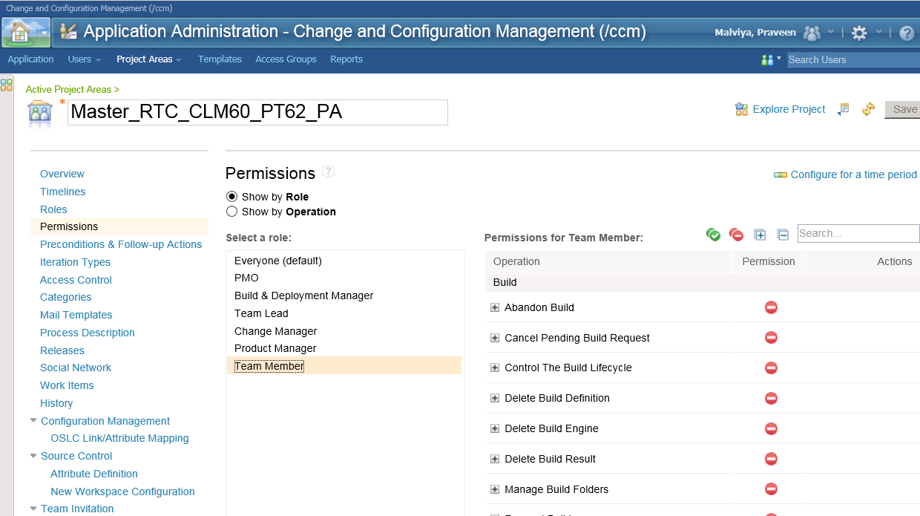

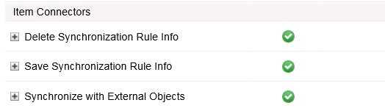

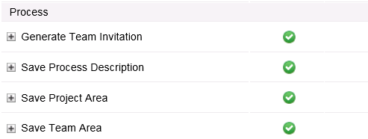

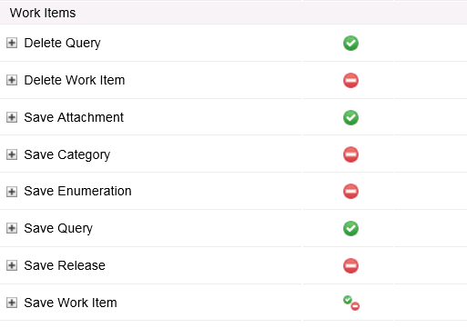

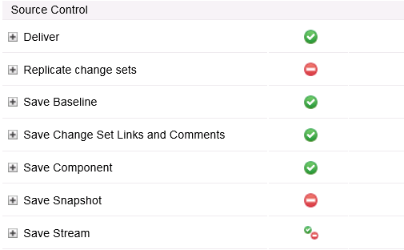

1. Add the same Jazz User as a Team Member to the RTC child Project Area.
2. The next step is to configure the Clear Case RTC Synchronizer.

## Configure the CC Importer

**Note:** Follow this section for migrate every UCM project.

* + - 1. Log in to the RTC Eclipse client and Go to **File🡪 Import 🡪 Jazz Source Control 🡪 select Clear Case Stream or Branch**. Click on Next.

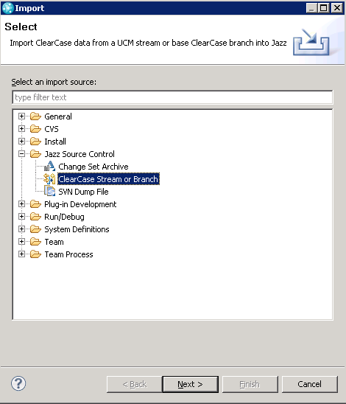

* + - 1. In the import wizard, Go to "**Import from an existing UCM stream**" and set the **ClearCase stream selector** to **"myproj_Integration@\rtcpvob**". Stream Selector

**Note:** Ensure "**Import with history from Clear Case**" is selected and this is an **iterative process** per UCM Project.

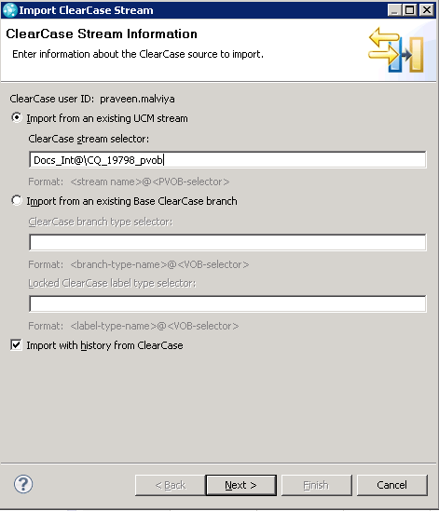

* + - 1. Set the "**UNC Path to a local share**" as **\\myhost\ccstg_c\views** (this is the view storage location path) and rest of the fields keep as it is as below screen and click Next.

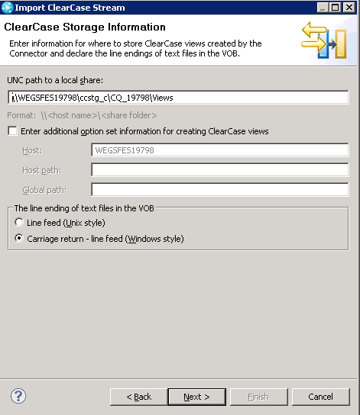

* + - 1. Select the “RTC PA" project area.

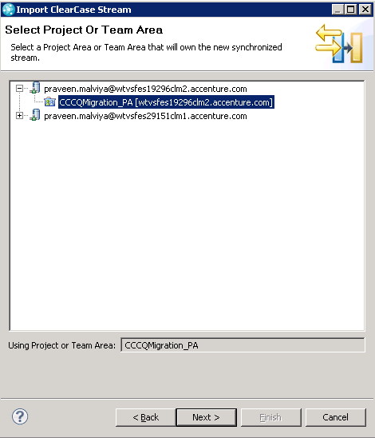

* + - 1. In the **Work Item template** section, click **Browse** and in the ensuing dialog, use the "**Create Work Item**" link to create a new Work Item of type **Task**.
      2. Create one Task into RTC for migration purpose and enter ID into **Work item ID** field.

**Note:** When you create Task work item for pass work item ID, make sure **Planned For** is selected.

* + - 1. In the "**Jazz Synchronization Engine options**" section, set the following values:

***User ID:*** *<enterprise id>****Password:*** *<enterprise password>****Install location: <****C:\IBM\ClearCaseSynchronizer\ccctools>*

* + - 1. Deselect **Start a Jazz Synchronization engine** as the Synchronization engine is started after the Clear Quest records have been imported.
      2. Select "**Start the Select Files wizard after this wizard finishes**".

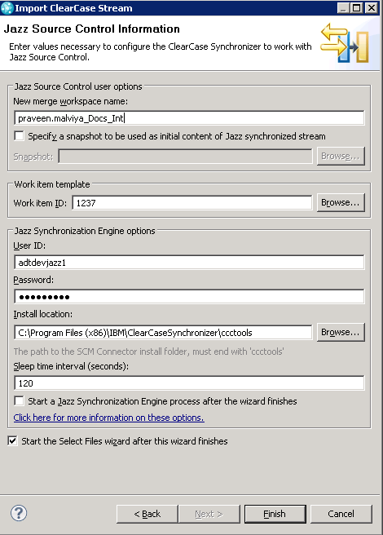

* + - 1. Click **Browse** 🡪 **Select component** and select the "**component**".

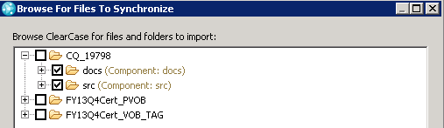

* + - 1. Component should be added and select Import all baseline. Click on Finish.

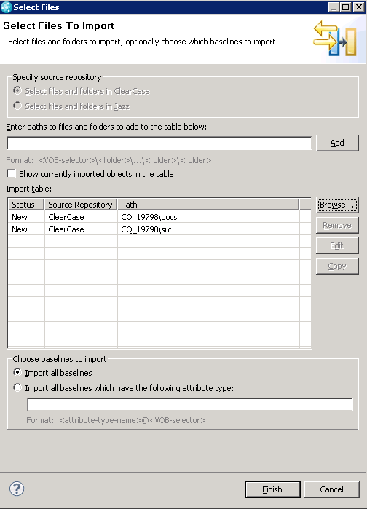

* + - 1. Once the Wizard completes, right-click the Synchronized Stream and select **Properties** from the context menu.

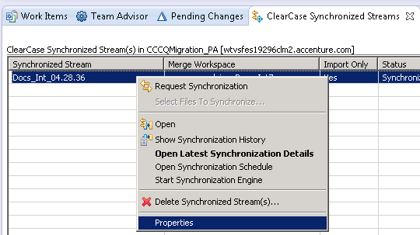

* + - 1. In the **Properties** dialog, select the **Clear Case Provider Properties** node and change the following properties:

**CLEARCASE_LOGIN_NAME:** Headless user account

**CLEARQUEST_DBSET_NAME:** CQ repository connection name

**CLEARQUEST_LOGIN_NAME:** Headless user account

**CLEARQUEST_USERDB_NAME:** CQ logical DB name

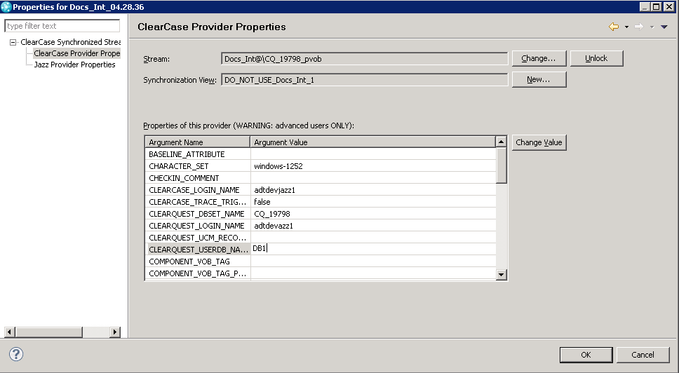

* + - 1. Click the "**Change Value**" button.
      2. Note the value of the **STREAM_SCRIPT_DIR** property, For example:   
         ***STREAM-SCRIPT_DIR:*** *C:\Documents and Settings\<username>\ClearCaseConnector\_bBLWkemfEd-xy8GaWRAPqQ.synchronizer*

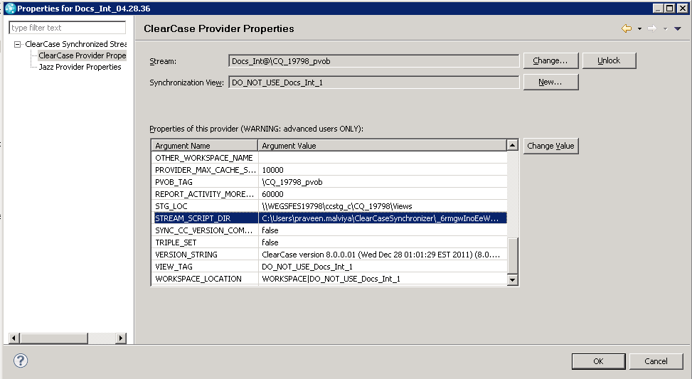

* + - 1. Navigate to this directory and create a text file named "**adtdevjazz1.cq_password**", noting that name portion of the file name exactly matches the value of the **CLEARQUEST_LOGIN_NAME** property. Edit the file with and add a single line to it:

***-password=password of admin account***

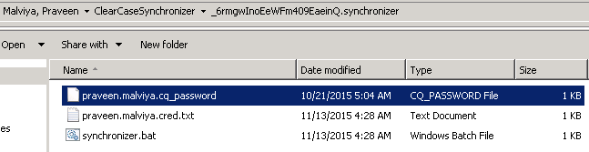

17) Click on OK button.

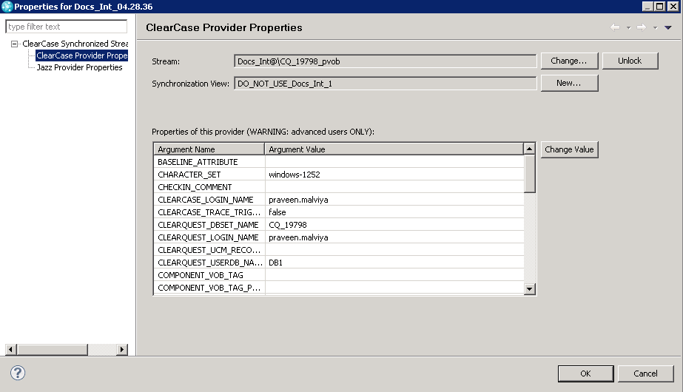

18) All the components are now configured and ready for the import.

19) Now launch the Jazz Clear Case Synchronization Engine process which will import the related Clear Case baselines and elements, linking them to the corresponding work items.

## Import the Clear Case UCM baselines

**Note:** Follow this section for migrate every UCM project.

1. Go to RTC Eclipse client.
2. Open clear case Synchronized Streams view, window 🡪 show view 🡪 others 🡪 Jazz Source control 🡪 select clear case synchronized stream and click Ok.
3. In the **Clear Case Synchronized Streams** view, right click the synchronized stream and from the context menu, select **Start Synchronization engine**.

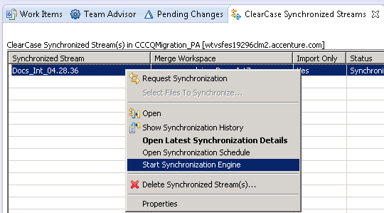

1. Once **Start Synchronization engine** is done, below screen will be populated and waiting for Request Synchronization.

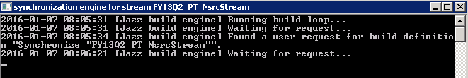

1. Right click on Synchronization stream and select Request Synchronization.

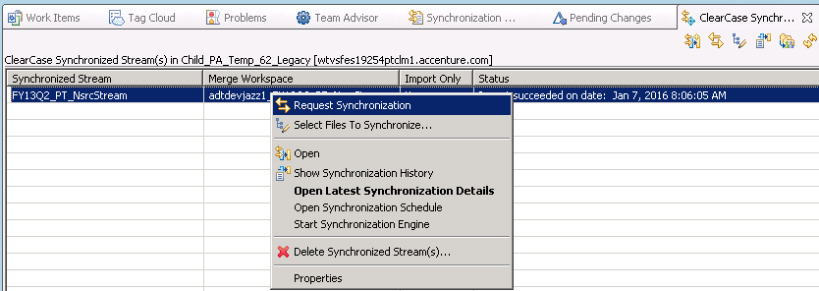

1. Once synchronization is done, status would be displayed as “Import Succeeded” in the **Clear Case Synchronized Streams** view.

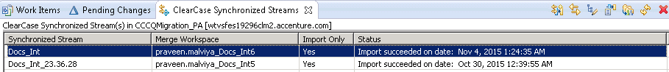

1. Once the import is completed, double click the Status to open the log which will provide details on what was synchronized, the duration, which work items were created to track the baselines imported ("**Included in build**") and links to detailed logs for troubleshooting if required.

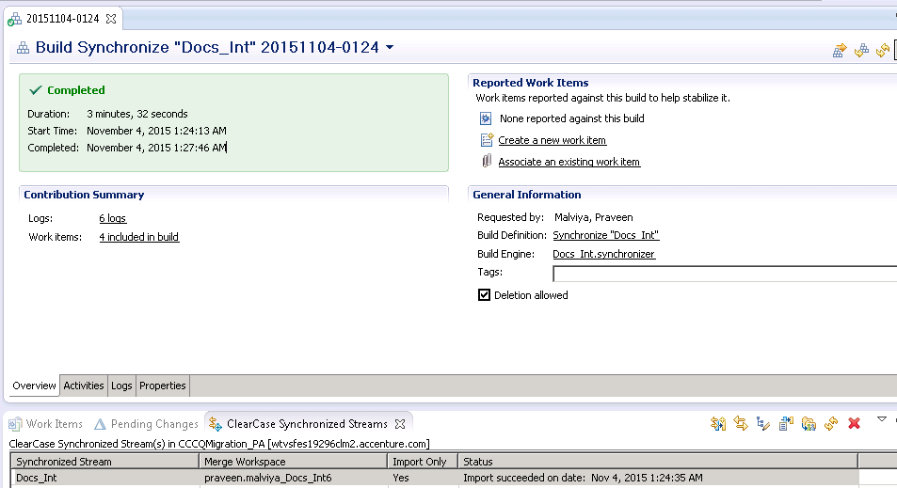

## Verifying the import

**Note:** Follow this section to migrate each UCM project.

1. Go to the **Pending Changes** view, select and right-click the components. Select **Accept** from the context menu.

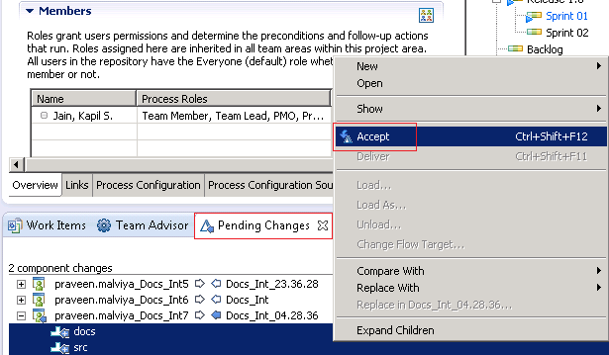

1. Click on Repository files tab, all components would be downloaded in your local workspace.

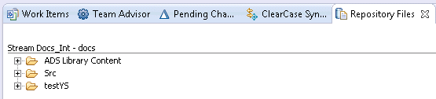

1. Migrated clear case repository should be visible under source control tab.

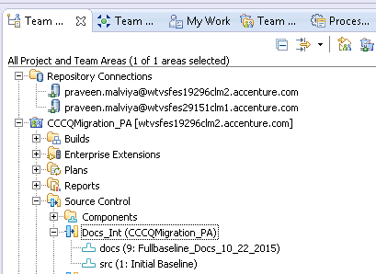

1. All incremental and full baseline migrate into RTC as a Change Sets. Execute task query and new task would be created by “Bring over:” name based on all incremental and full baselines.

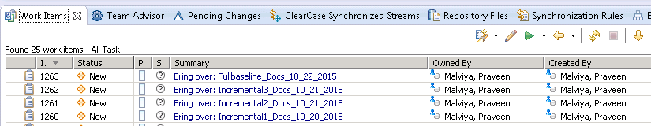

1. All migrated activities are added into Description section based on the previous baseline.

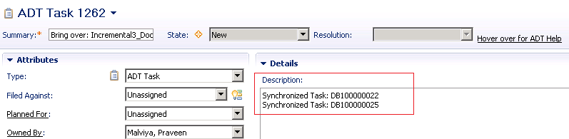

1. If you need to see how many files are updated in particular baseline then open particular change set under the Link tab, all updated files will be listed under change summary.

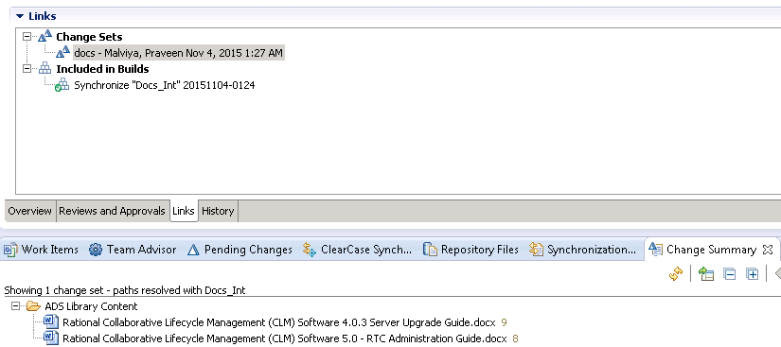

1. Verify the migration at record level and check activity in CQ. Verify that the files are checked-in/checked-out by the activity in CC and then open same activity as a migrated task into RTC. Open link tab and under the change sets, all the change sets would be created using the same activity in incremental/full baseline.

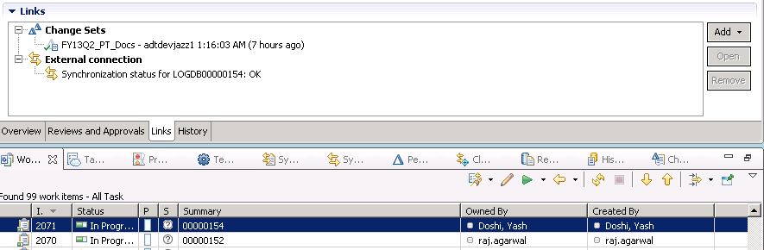

## Find Stream Selector

1. Open Project Explorer in your CC server.
2. Expand CC project and right click on stream that needs to be migrated.



1. Copy Stream Selector.

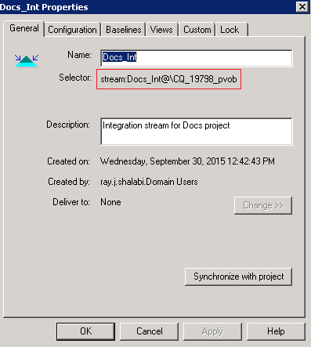

## Find component list in RTC

This section would cover how to verify CC component list into RTC once the UCM projects are migrated into RTC.

1. Login into RTC eclipse client and expand stream that is just migrated under source control in the RTC PA.

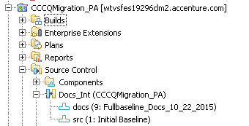

1. Open component and change Owned by field to either RTC PA name or Team Area name.

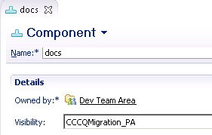

1. Expand components into RTC PA, verify components list.

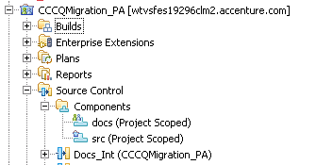

1. If components are being used by multiple UCM projects, common components are created only once while migrating such UCM projects.

# Troubleshooting

1. If users are unable to check-in/check-out the files in their repository by Clear Team Explorer then ensure active Clear Case Group is set as a primary group in their Groups.

Open Clear Team Explorer 🡪 Windows 🡪 Preferences 🡪 Group and set clear case group as a primary group.

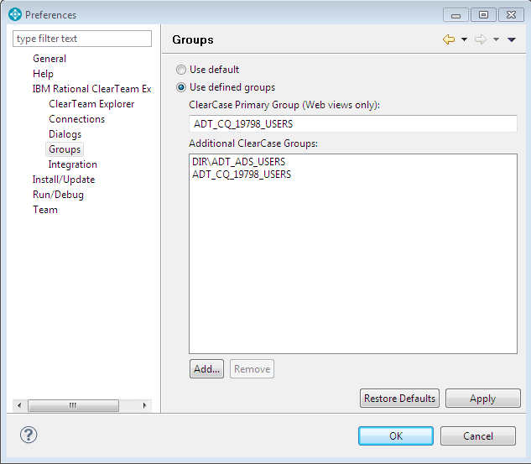

1. During configure migration steps, if administrator is unable to add components list using **Browse** option, then please follow below instructions to resolve the same.

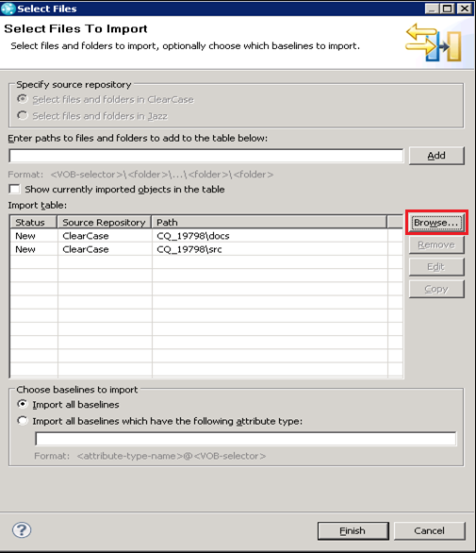

1. Log in to the Host where the RTC Import from CC will be executed.
2. On that host, create a *User* environment variable (Not a System Environment Variable) named CLEARCASE_PRIMARY_GROUP.
3. Set the value of the CLEARCASE_PRIMARY_GROUP Environment Variable to the name of the group used by the VOB, for example, ADT_<ProjectCode>_USERS
4. Log off the host
5. Log back in
6. Start the RTC Import process

# Rollback Procedure

The CC server is not impacted during the CC - RTC migration because the migration takes place using CC Synchronization engine.

If at any point the migration fails, then the files which have been migrated will remain intact. And for the CC repository which were not migrated, re-execute the Synchronization engine and all the files that were not migrated will be created in RTC source control.

**Note:** There will be no CC data loss if the migration fails in between. Re-execute the Synchronization engine and new files would be created based on incomplete CC repository. The files already migrated will remain unaffected.

In case if it is fails again, then also the CC server would remain as it is and there will be no data loss on the CC Server.